**Program:**

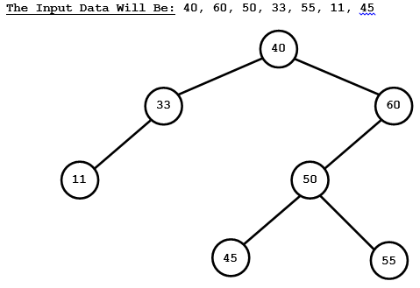

**#include<stdio.h>**

**#include<conio.h>**

**#include<alloc.h>**

**struct BINARY_S_TREE**

**{**

**BINARY_S_TREE *left;**

**int info;**

**BINARY_S_TREE *right;**

**};**

**BINARY_S_TREE *root;**

**void CREATE_TREE(BINARY_S_TREE *loc, int data)**

**{**

**BINARY_S_TREE *FRESH;**

**if(data==loc->info)**

**{**

**printf("DUPLICATE VALUE OF NODE INFORMATION\n");**

**return;**



**}**

**else if(data<loc->info)**

**{**

**if(loc->left != NULL)**

**{**

**CREATE_TREE(loc->left,data);**

**}**

**else**

**{**

**printf("INSERTING TO LEFT\n");**

**FRESH=(BINARY_S_TREE *) malloc (sizeof(BINARY_S_TREE));**

**FRESH->info=data;**

**FRESH->left=FRESH->right=NULL;**

**loc->left=FRESH;**



**} }**

**else**

**{**

**if(loc->right != NULL)**

**{**

**CREATE_TREE(loc->right,data);**

**}**

**else**

**{**

**printf("INSERTING TO RIGHT\n");**

**FRESH=new BINARY_S_TREE;**

**FRESH->info=data;**

**FRESH->left=FRESH->right=NULL;**

**loc->right=FRESH;**

**}**

**}**

**}**